Project Design Phase-II Technology Architecture

|  |  |
| --- | --- |
| Date | 8th November 2022 |
| Team ID | PNT2022TMID38955 |
| Project Name | Plasma Donor Application |
| Maximum Marks | 4 Marks |

**Technology Architecture:**

Project full fill the following information in this technology architecture.

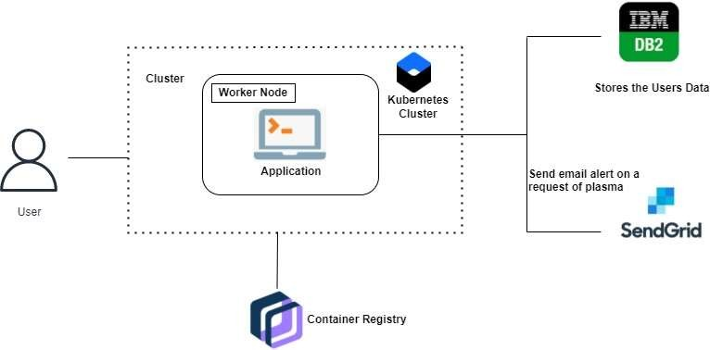

|  |  |  |
| --- | --- | --- |
| **Sl.No** | **Parameter** | **Description** |
| 1. | Is the System Robust? | Yes, the system is robust that it can’t be crashed intermittently and it has been tested  for several times before placing it to the high availability environment. |
| 2. | Is it highly modifiable? | Yes, the system is modifiable and it can admit to the changes by detecting errors that needs  to be fixed and new functionalities. It is highly Responsive changes. |
| 3. | Is it Scalable? | Yes, the system proposed is highly scalable as it can handle the growing workload where good performance is also needed to work efficiently. Deployment of the platform has been done using various OS virtualization platform it will  handle the workload statistically. |
| 4. | Is it buildable? | Yes, it is partially buildable platform as the budget required will be more as cloud is a pay per use model and time taken will be quite  comparatively less. |